Curriculum Vitae (CV)
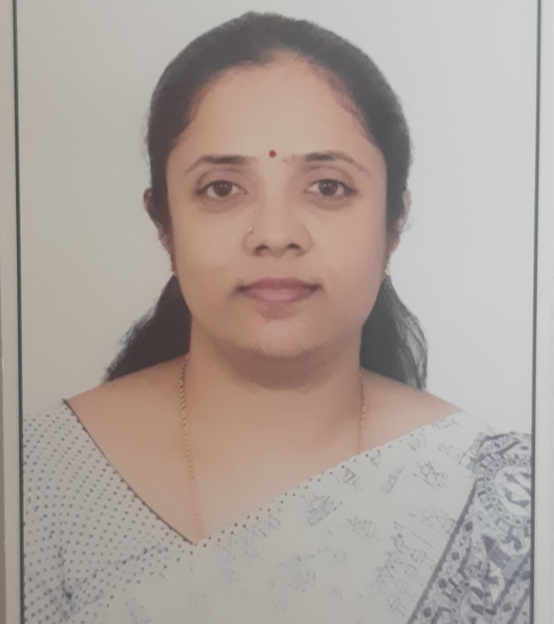
Name: B.M. Lakshmi
Assistant Professor,
Vijaya Teachers College-CTE
Jayanagar 4th Block,
Bengaluru-11
Corresponding Address:
# 89, Sri Badari Nivas, 3rd main,
Eshwar Layout, J.P. Nagar 7th Phase,
Bengaluru. 560062.
Contact: 91-9739839930
Email- lakshmibmrao@gmail.com

Professional Goal:
Be a committed learner and an inspiring Teacher Educator.

Profile:
Passionate about teaching, learning and research in the field of Education. Committed towards student’s progress. Pursuing Ph.D. under the Research Guide Prof. Anilkumar K., Associate Professor, RIE, Mysore.

Skills:
- Communication skill
- ICT Integrated Pedagogy
- Empathetic
- Class management
- Guidance & Counseling for students
- Mentoring the students
- Innovative Instructional Strategies
- Time-table planning
- Virtual teaching & assessment using advanced digital tools and applications.
Academics Chronicles:

ACADEMIC CHRONICLE
Sl. No | Name of the course | Specialization | Institution | University | Year Of Graduation
01 | B.Sc | Chemistry, Botany & Microbiology | SSMRV Degree College | Bangalore | 2002
02 | M.Sc | Microbiology | P.E.S. College | Bangalore | 2004
03 | B.Ed | Chemistry & Biology | Vijaya Teachers College-CTE | Bangalore | 2015
04 | M.Ed | ICT & Elementary level | Department of Education, Vijaya Teachers College-CTE. | Bangalore | 2017
05 | Ph.D | Education | RIE- Mysore | Mysore | Pursuing
Qualifications: UGC- NET, K-SET
Academic Chronicle related to ICT
01 | Web 2.0 tool | Collaborative tools |  | University of Houston | 2018
02 | Cybergogy for Engaged Learning | Usage of Mobile & Desktop application in Higher education. |  | Central University of Kerala | 2018
03 | E-Assessment | Google Form, Online quiz |  | SNDT Women University of Mumbai | 2019
04 | ICT Applications | Google Apps, H5P, Mind map, Infographic... |  | SNDT Women University of Mumbai | 2020
05 | FDP | Google Application, Video podcasting and LMS |  | Ramanujan College of Delhi | 2020

Professional Experience :
Teaching experience of 6.1 years as a Teacher Educator in B.Ed and M.Ed ( 1 Year).

As a Resource Person :
- RIE, Mysore for Development of training package of In- service teachers on TPACK in Science for Secondary School level in 0ctober 2017.
- East-West school One-Day orientation on Curriculum and Pedagogy of Biological Science, in 2018.
- Badarikashrama Vaidya Shale - One-Week Teacher orientation on ICT in Education in 2018.
- Government High School, Kakol- Address the 10th std students in preparing for Board Examination in february 2019.
- SAMVIT Foundation of Rashtrotthana Vidya Samstha as Pedagogy expert in Developing Pride Of India (POI) Curriculum Development in Biology for Higher Primary & Secondary School level in April, 2020.
- Prarthana School as a resource person in teacher orientation workshop on 5 E Lesson Plan Approach in Biology in May 2020.
- Participated as one of the panelist in Manodarpan program, organized by NCERT, on “Mental well-being of adolescents” on 14.07.2023.
Personal Particulars:
Name :B.M. Lakshmi

Father’s Name :D.S. Krishnaswamy

Mother’s Name :Padma Krishnaswamy

Date of Birth :27-06-1981

Gender :Female

Marital Status :Married

Languages Known : Kannada, English, Hindi & Telugu

Nationality : Indian

Blood Group : A +ve

Permanent Address : #89, Sri Badari Nivas, 3rd Main, Eshwar Layout, J.P. Nagar 7th Phase, Bengaluru- 560062

DECLARATION
I hereby declare that all information furnished above is true to the best of my knowledge and belief.

Date : 14-07-2023

Place : Bengaluru

